Implement the class MovieTicket with the instance variables and methods mentioned below.
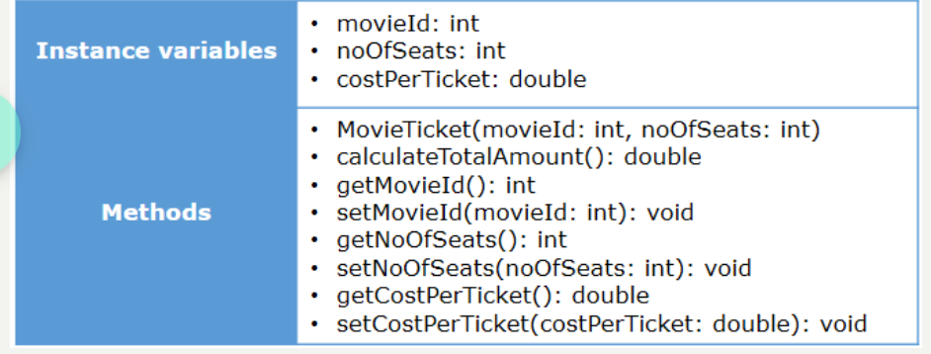
Method Description
MovieTicket (int movieId, int noOfSeats)
- Initialize the member variables movieId and noOfSeats appropriately with the values passed to the constructor.
calculateTotalAmount()
- Calculate the total amount to be paid based on the costPerTicket and noOfSeats by applying a 2% tax on the total amount.
- The costPerTicket for the movies are provided in the below table. Set the value of costPerTicket instance variable appropriately.
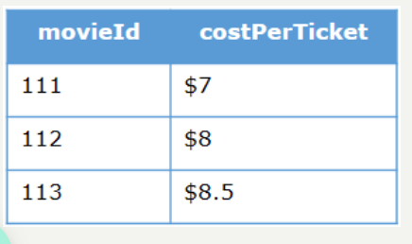
- Note: Return the total amount calculated after rounding off using the Math.round(double a) method.
Test the functionalities using the provided Tester class.

Sample Input and Output
Input
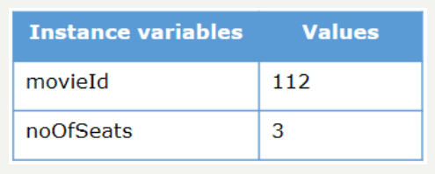
Output
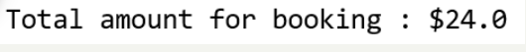
Input
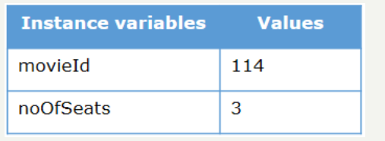
Output

